**WEEK 03**

**Problem Statement:**

Write a program to read two integer values and print true if both the numbers end with

the same digit, otherwise print false.

Example: If 698 and 768 are given, program should print true as they both end with 8.

**Sample Input 1**

25 53

**Sample Output 1**

false

**Sample Input 2**

27 77

**Sample Output 2**

True

**Program**

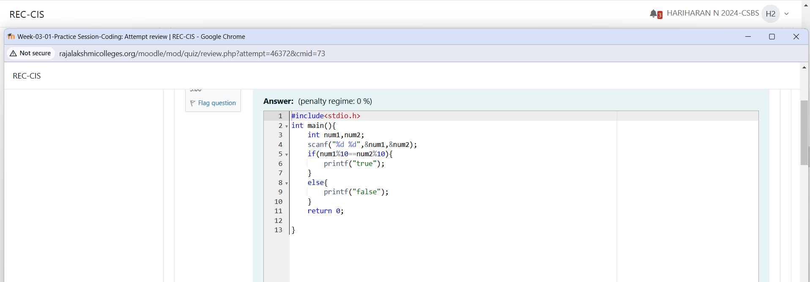

**Output**

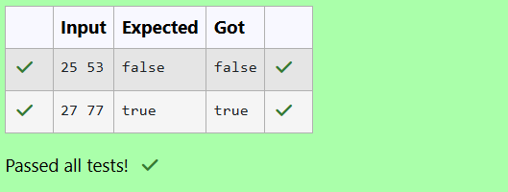

**Problem Statement:**

In this challenge, we're getting started with conditional statements.

Task

Given an integer, n, perform the following conditional actions:

• If n is odd, print Weird

• If n is even and in the inclusive range of 2 to 5, print Not Weird

• If n is even and in the inclusive range of 6 to 20, print Weird

• If n is even and greater than 20, print Not Weird

Complete the stub code provided in your editor to print whether or not n is weird.

**Input Format**

A single line containing a positive integer, n.

**Constraints**

• 1 < n < 100

**Output Format**

Print Weird if the number is weird; otherwise, print Not Weird.

**Sample Input 0**

3

**Sample Output 0**

Weird

**Program**

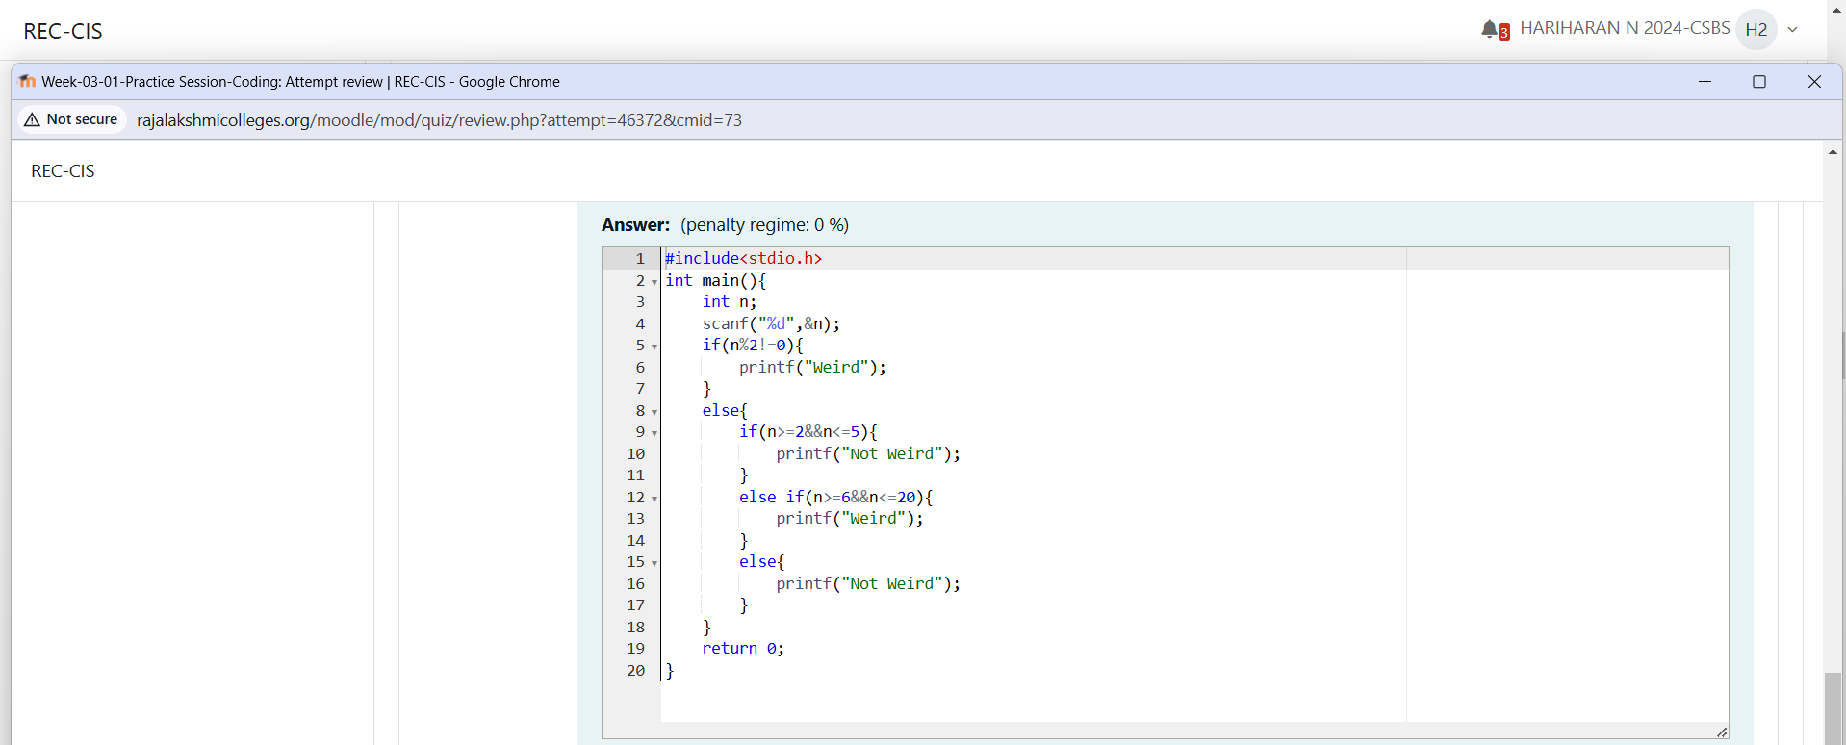

**Output**

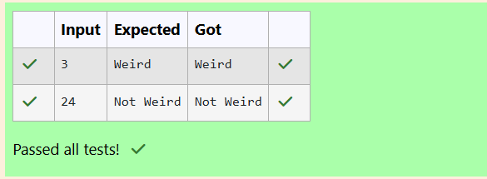

**Problem Statement:**

Three numbers form a Pythagorean triple if the sum of squares of two numbers is equal to

the square of the third.

For example, 3, 5 and 4 form a Pythagorean triple, since 3*3 + 4*4 = 25 = 5*5

You are given three integers, a, b, and c. They need not be given in increasing order. If

they form a Pythagorean triple, then print "yes", otherwise, print "no". Please note that the

output message is in small letters.

**Sample Input 1**

3

5

4

**Sample Output 1**

Yes

**Program**

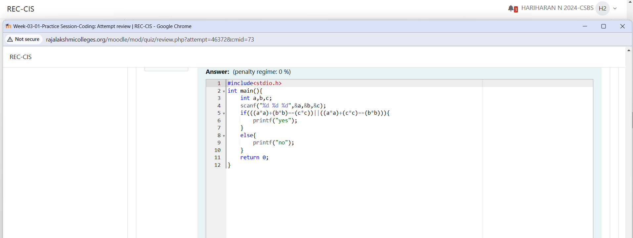

**Output**

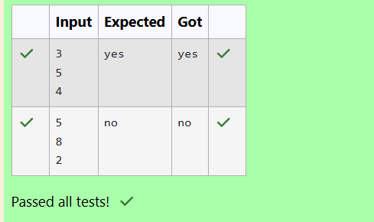

**Problem Statement:**

Write a program that determines the name of a shape from its number of sides. Read the

number of sides from the user and then report the appropriate name as part of a

meaningful message. Your program should support shapes with anywhere from 3 up to

(and including) 10 sides. If a number of sides outside of this range is entered then your

program should display an appropriate error message.

**Sample Input 1**

3

**Sample Output 1**

Triangle

**Sample Input 2**

7

**Sample Output 2**

Heptagon

**Sample Input 3**

11

**Sample Output 3**

The number of sides is not supported.

**Program**

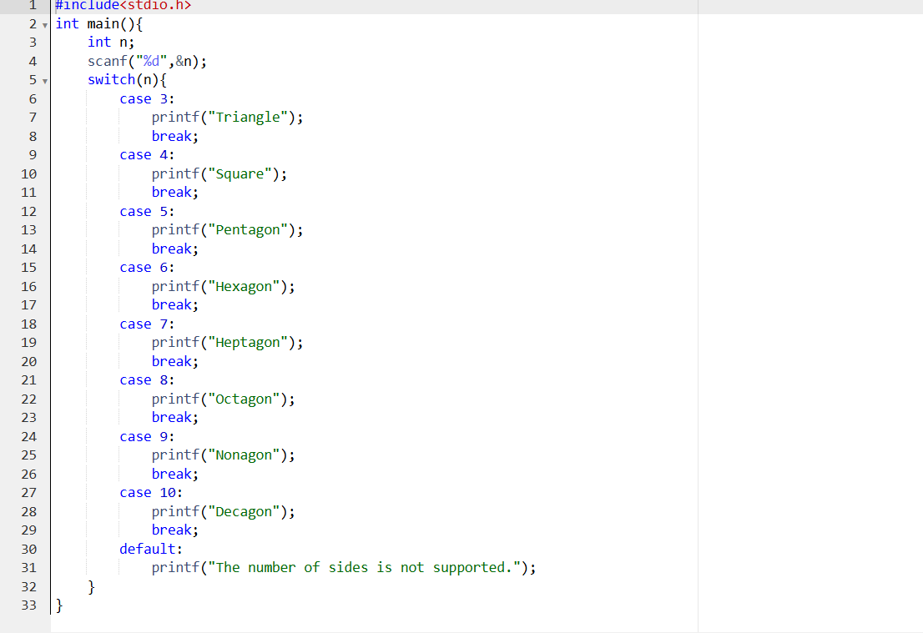

**Output**

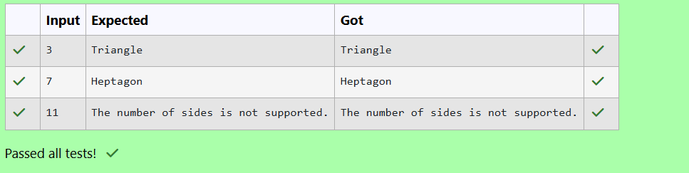

**Problem Statement:**

The Chinese zodiac assigns animals to years in a 12-year cycle. One 12-year cycle is

shown in the table below. The pattern repeats from there, with 2012 being another year of

the Dragon, and 1999 being another year of the Hare.

Year Animal

2000 Dragon

2001 Snake

2002 Horse

2003 Sheep

2004 Monkey

2005 Rooster

2006 Dog

2007 Pig

2008 Rat

2009 Ox

2010 Tiger

2011 Hare

Write a program that reads a year from the user and displays the animal associated with

that year. Your program should work correctly for any year greater than or equal to zero,

not just the ones listed in the table.

**Sample Input 1**

2004

**Sample Output 1**

Monkey

**Sample Input 2**

2010

**Sample Output 2**

Tiger

**Program**

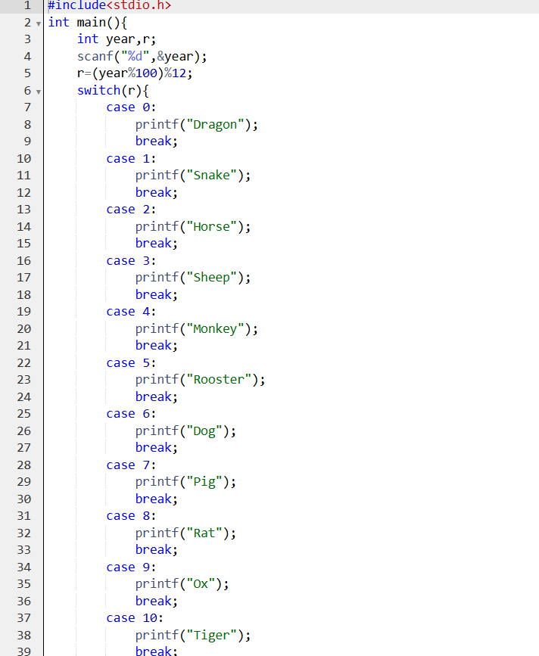

**Output**

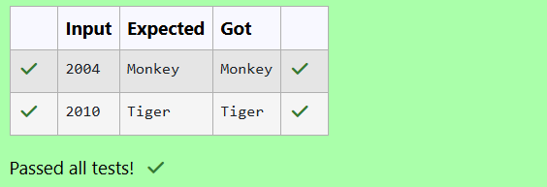

**Problem Statement:**

Positions on a chess board are identified by a letter and a number. The letter identifies the

column, while the number identifies the row, as shown below:

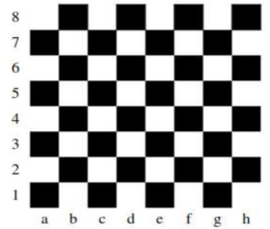

Write a program that reads a position from the user. Use an if statement to determine if the

column begins with a black square or a white square. Then use modular arithmetic to

report the color of the square in that row. For example, if the user enters a1 then your

program should report that the square is black. If the user enters d5 then your program

should report that the square is white. Your program may assume that a valid position will

always be entered. It does not need to perform any error checking.

**Sample Input 1**

a 1

**Sample Output 1**

The square is black.

**Sample Input 2**

d 5

**Sample Output 2**

The square is white.

**Program**

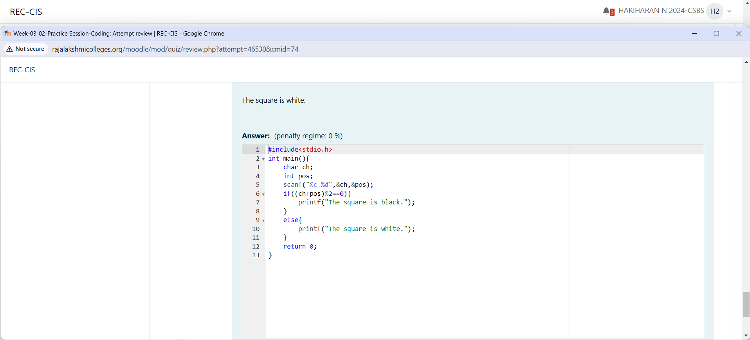

**Output**

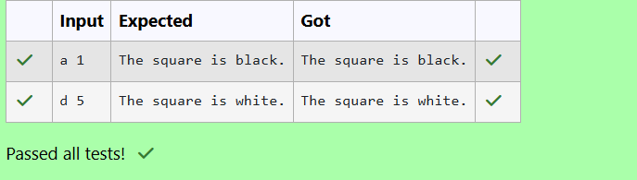

**Problem Statement:**

Some data sets specify dates using the year and day of year rather than the year, month,

and day of month. The day of year (DOY) is the sequential day number starting with day 1

on January 1st.

There are two calendars - one for normal years with 365 days, and one for leap years with

366 days. Leap years are divisible by 4. Centuries, like 1900, are not leap years unless

they are divisible by 400. So, 2000 was a leap year.

To find the day of year number for a standard date, scan down the Jan column to find the

day of month, then scan across to the appropriate month column and read the day of year

number. Reverse the process to find the standard date for a given day of year.

Write a program to print the Day of Year of a given date, month and year.

**Sample Input 1**

18

6

2020

**Sample Output 1**

170

**Program**

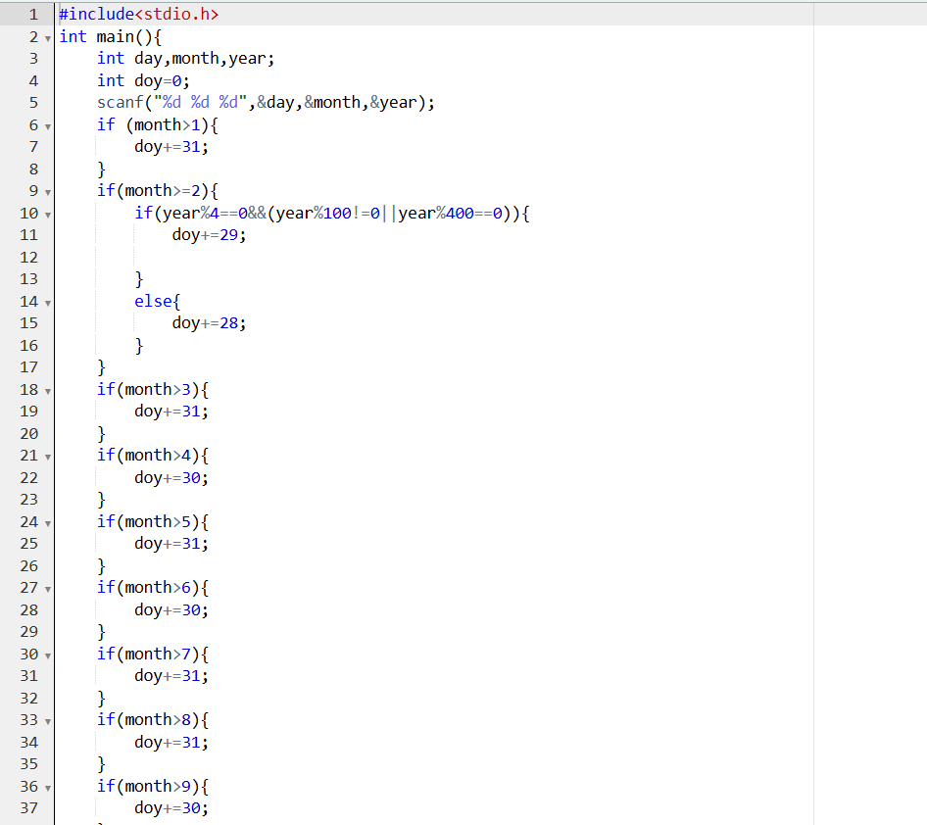

**Output**

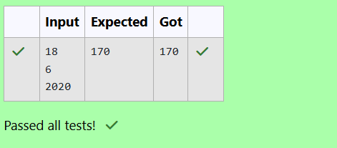

**Problem Statement:**

Suppandi is trying to take part in the local village math quiz. In the first round, he is asked

about shapes and areas. Suppandi, is confused, he was never any good at math. And also,

he is bad at remembering the names of shapes. Instead, you will be helping him calculate

the area of shapes.

• When he says rectangle, he is actually referring to a square.

• When he says square, he is actually referring to a triangle.

• When he says triangle, he is referring to a rectangle

• And when he is confused, he just says something random. At this point, all you can

do is say 0.

Help Suppandi by printing the correct answer in an integer.

**Input Format**

• Name of shape (always in upper case R --> Rectangle, S --> Square, T --> Triangle)

• Length of 1 side

• Length of other side

Note: In case of triangle, you can consider the sides as height and length of base

**Output Format**

• Print the area of the shape.

**Sample Input 1**

T

10

20

**Sample Output 1**

200

**Program**

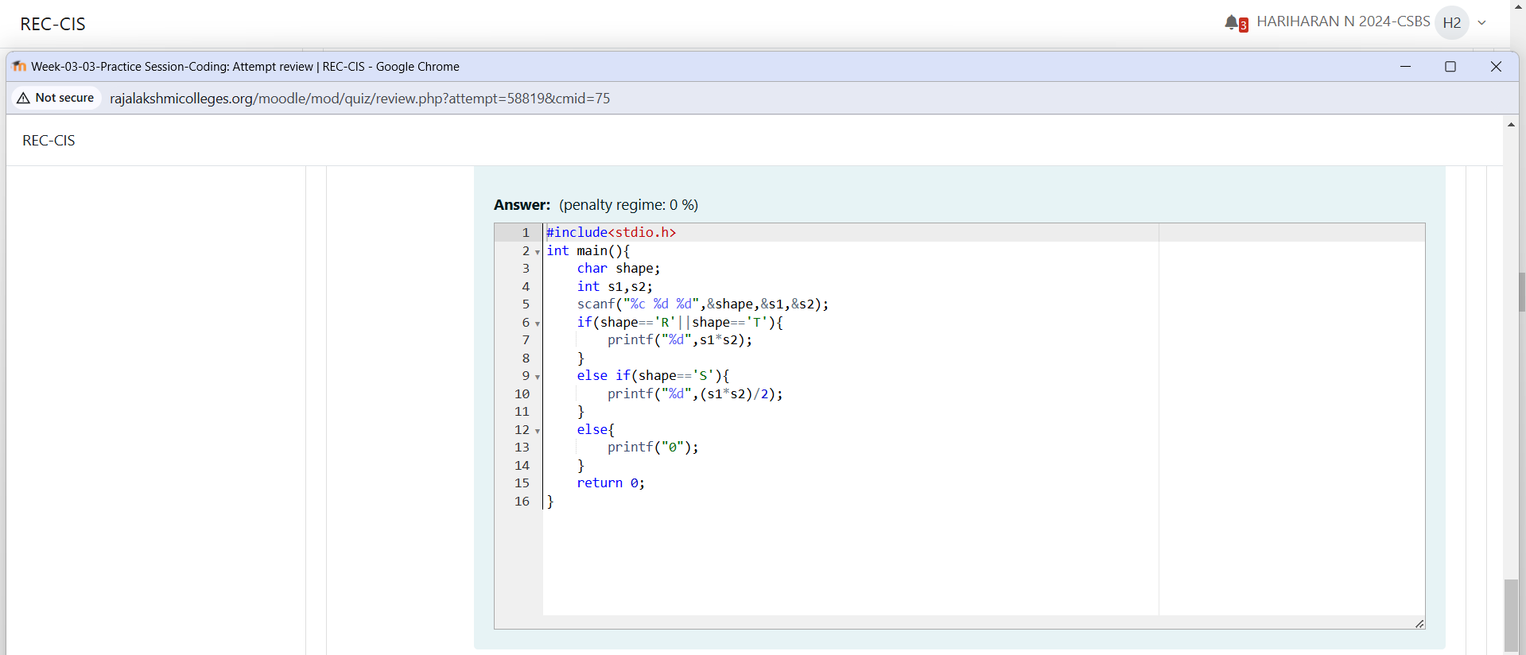

**Output**